Wearlane Checkout: Integration & Verification Report

Project: Retake-it Agile Group 1
Feature: Integration & Verification Report
Tester: Stanley Chidi Ohakaba
Date: 02/10/2026
Device/Browser: Google Chrome browser and Automated Node.js test environment
Status: Unchanged
Assignee: Unchanged

Date: 3 October 2026 · Prepared for: Stanley · Source: wearlane-checkout.zip (Retake-it-agile-group-1)

Summary
The checkout source in the zip is complete and passes all automated checks: 36 of 36 tests pass and the production build succeeds. The code review matches every acceptance criterion. Browser testing (manual cases C01–C11), the source commit/branch link, and the live deployment are still unverified, so checkout must not be described as deployed yet.

Scope
Login-required checkout, required-field validation, fictional payment, and order confirmation. Status and assignee are unchanged. The shared-repository gap is that the actual source and tests with a commit/branch reference have not been pushed.

What was done
- Unpacked the zip and inspected the source (src/main.jsx, src/domain.js, tests/, deploy workflow).
- Installed dependencies, ran npm test, and ran npm run build.
- Reviewed the checkout code paths against the acceptance criteria in docs/CHECKOUT_TEST_COMMENT.md.

Results

Automated
Check | Result
npm test (Node 22.22) | 36 pass, 0 fail
npm run build (Vite 7) | Success, 27 modules, JS 253.7 kB (79 kB gzip)

Code review against acceptance criteria
Criterion | Finding
Requires sign-in and non-empty cart | /checkout shows "Sign in to check out" when signed out and "Nothing to check out" when the cart is empty. Sign-in returns to /checkout via ?next=.
Address validated with clear errors | validateCheckout checks name, street, city and postcode, with a specific message per field.
Simulated payment, no real card data | Payment is a dropdown (success or decline). No card fields exist.
Declined payment keeps the cart | Decline returns before createOrder, so the cart is untouched and no order is saved.
Success creates order, clears cart, shows confirmation | Order saved with a WL- reference, cart cleared, redirect to /order/<ref> showing address, lines and total.
Confirmation not leaked | Confirmation only renders for the account that placed the order. Others see "Order not found".

Not verified
- Manual cases C01–C11 have not been run in a browser, including the 360 px layout, confirmation refresh, and signed-out confirmation URL. The Jira comment cannot be filled in honestly until they are.
- Source provenance: the zip contains no .git folder, so the matching commit or branch is unknown and nothing could be pushed from here.
- Live site: the GitHub Pages URL was not checked. The workflow deploys on push to main, so checkout is live only after this source reaches main and the Actions run is green.
- Environment difference: CI uses pnpm on Node 24; local verification used npm on Node 22.

Risks
Risk | Impact | Mitigation
Source not in shared repo | Team cannot reproduce or deploy | Push source and tests, record commit/branch
pnpm/Node 24 vs npm/Node 22 | CI could behave differently | Confirm the Actions run passes
UI untested in browser | Visual or flow regressions unseen | Run C01–C11 on the live URL

Evidence
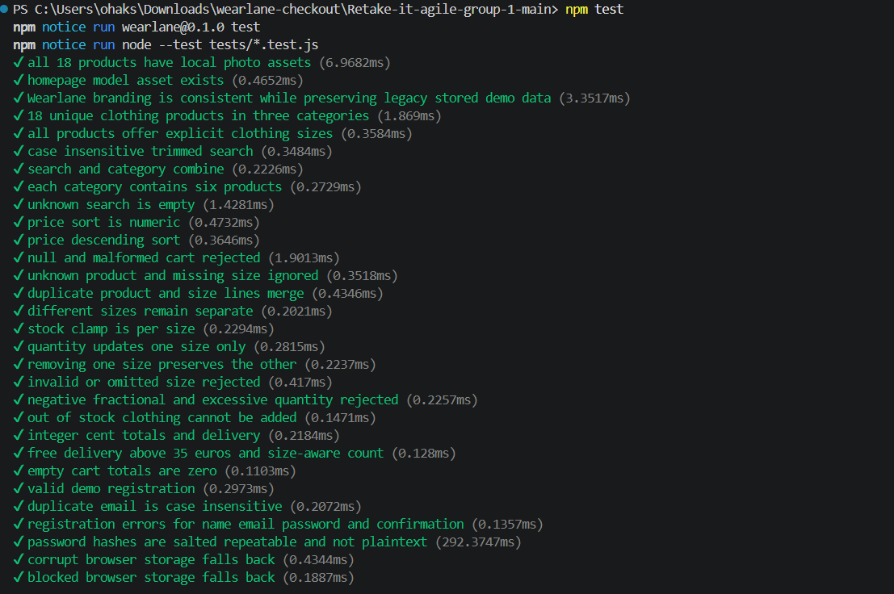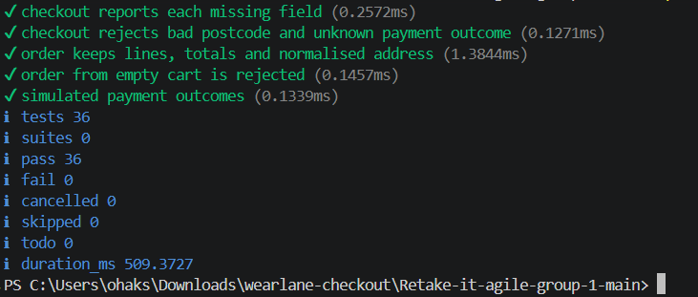

Next steps
- Push the source and tests to the shared repository and note the commit/branch.
- Confirm the GitHub Actions run (tests, build, deploy) is green.
- Run manual cases C01–C11 on the live site and complete the Jira comment.
- Only after step 3 passes, mark checkout as deployed and move the task to Done.

